Landscape & Irrigation System Monthly Service Report

Client | Emirates National Oil Company (ENOC) | Facilities Management | Farnek Services LLC
Location | ENOC Complex | JOB CODE | 22A&B11501
Service Provided | Landscape & Irrigation Maintenance Indoor Plants Arrangements Maintenance | Month | August 2026

ANNUAL PROACTIVE PLAN MAINTENANCE
Activities | Frequency | Jan. | Feb. | Mar. | April | May | June | July | Aug. | Sep. | Oct. | Nov. | Dec.
General cleaning/Removal of debris | Daily | ● | ● | ● | ● | ● | ● | ● | ● | ● | ● | ● | ●
Checking of water availability | Daily | ● | ● | ● | ● | ● | ● | ● | ● | ● | ● | ●
Hand-watering of Pots | Daily | ● | ● | ● | ● | ● | ● | ● | ● | ● | ● | ●
Lawn Mowing, Sweeping & Edging | Weekly | ● | ● | ● | ● | ● | ● | ● | ● | ● | ● | ● | ●
Pruning Shrubs & Hedges | Monthly | ● | ● | ● | ● | ● | ● | ● | ● | ● | ● | ● | ●
Pruning Groundcovers | Monthly | ● | ● | ● | ● | ● | ● | ● | ● | ● | ● | ● | ●
Weeding | Monthly | ● | ● | ● | ● | ● | ● | ● | ● | ● | ● | ● | ●
Soil Cultivation | Monthly | ● | ● | ● | ● | ● | ● | ● | ● | ● | ● | ● | ●
Trees (Crown Thinning, cleaning) | Bi-Monthly | ● |  | ● |  | ● |  | ● |  | ● |  | ●
Fertilization | Quarterly |  | ● |  |  | ● |  |  |  | ● |  | ●
Palm Trees Services | Quarterly |  | ● |  | ● |  |  |  | ● |  |  |  | ●
Irrigation Maintenance | Quarterly | ● |  |  | ● |  |  | ● |  |  | ●
Irrigation Controller timing change | Quarterly |  |  |  | ● |  |  |  | ● |  |  | ●
Replacement of Seasonal Flowers | Quarterly |  |  | ● |  |  | ● |  |  |  | ●
Agriculture Pest Control | Half Yearly + As required |  |  |  | ● |  |  |  |  | ●
Lawn Aeration, Verticutting | Half Yearly |  |  |  |  |  | ● |  |  |  |  |  | ●
Lawn Top-dressing | Annual |  |  |  |  | ●
Indoor Plants Maintenance | Weekly | ● | ● | ● | ● | ● | ● | ● | ● | ● | ● | ● | ●

OPERATIONS PERFORMANCE
PPM TASKS Carried-out during the Month:
Activity | Frequency | Complete (✓) | Pending (✗) | Remarks
General cleaning/Removal of debris | Daily | ✓
Checking of water availability | Daily | ✓
Hand-watering of Pots | Daily | ✓ |  | Everyday
Lawn Mowing, Sweeping & Edging | Weekly | ✓ |  | Every Saturday
Pruning Shrubs & Hedges | Weekly | ✓
Pruning Groundcovers | Monthly | ✓
Weeding | Monthly | ✓
Soil Cultivation | Monthly | ✓
Trees (Crown Thinning, cleaning) | Bi-Monthly | ✓
Indoor Plants Maintenance | Weekly | ✓ |  | Every Friday & Sunday

.

Irrigation Water Meter Consumption Log (New Water Meter reader Installed during the month of February)

Month | January 2026 | Feb 2026 | March 2026 | April 2026 | May 2026 | June 2026 | July  2026 | August 2026 | Sept 2026 | Oct  2026 | Nov 2026 | Dec 2026
Total Monthly Consumption (m3) | 265.89 m3 | 86.16 m3 | 263.48 m3 | 721.56 m3 | 462.10 m3 | 404.78 m3 | 406.50 m3 | 278.67 m3

EXTRA OR PENDING TASKS Carried-out during the Month:
S/N | Description
01 | Application of “PROSPERITA” Fertilizer for the Delonix tree at the entrance roundabout have been carried out.
02 | Application of Desert Energy (12-12-17+ 2MgO + TE) NPK fertilizer for the Thevetia peruviana & Hibiscus Potted plants carried out.
03 | Replacement of 02 no. Unhealthy Hibiscus Potted Plants have been carried out.
04 | Application of Pesticides for the Palm trees using Lamda Cyhalothrin carried out.

REACTIVE MAINTENANCE TASKS Carried-out during the Month:
S/N | Description
01 | N/A

OPERATIONAL CONSTRAINS
S/N | Incident Description | Status
01 | N/A | N/A

OPERATIONS CONTACT DETAILS
Role | Name | Phone | Email
Project Engineer | Renin Amaldass | 052 848 0153 | renin@italianplanters.com
Supervisor | Daud | 054 454 1032
Operations Coordinator | Ebin Shiji | 052 848 0151 | operations@italianplanters.com

OSH TRAINING
- Emergency rescue plan
- COSHH & spillage procedure
- Fire Safety
- Common falling object

ASSET LIST

Outdoor Landscaping Asset List
S/N | Category | Plants | Qty
01 | Palms | Phoenix dactylifera (Date Palms), Washingtonia robusta | 09 no.
02 | Shrubs + Ground covers | Bougainvillea Glabra, Thevetia peruviana, Jatropha integrrima, Ipomoea pes-caprae, Jasminum sambac, Pandanus baptistii variegata, Agave americana, Ruellia Rosea & Asystatia giganetica. | 1780 m2
03 | Lawn | Paspalum vaginatum | 450 m2
03 | Seasonal Flowers | Vinca Rosea, or Petunia or portulaca grandiflora | 4400 no.
Indoor Plants Asset List
Location | ENOC House 01 | ENOC House 02 | ENOC House 03
Ground Floor | 59 | 24 | 25
1st Level | 46 | 45 | 40
2nd Level | 42 | 31 | 49
3rd Level | 70 | 32 | 10
4th Level | 69 | 33 | 32
LR+M | 0 | 10
Terminal | 0 | 48
IT Spectrum | 6
Total | 292 | 223 | 156

PHOTOGRAPHS
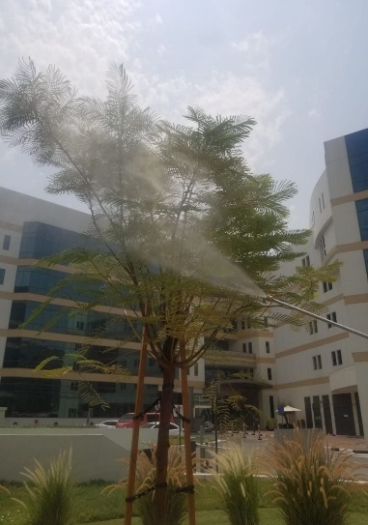 | 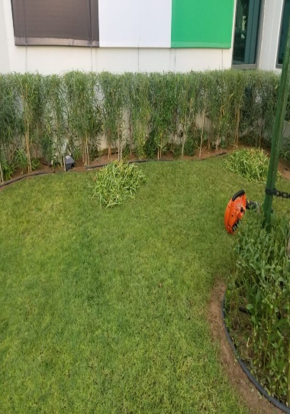 | 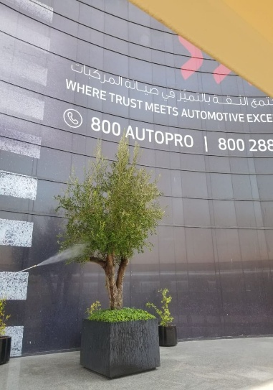 | 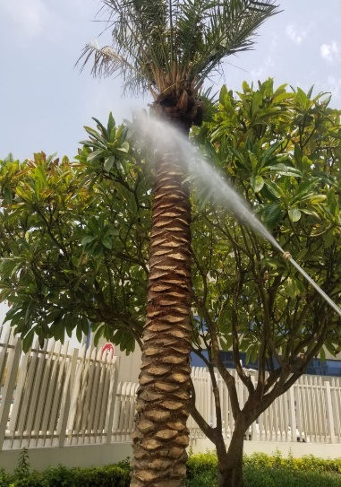
Application of Pesticides | Trimming Activity | Application of Pesticides | Application of Pesticides
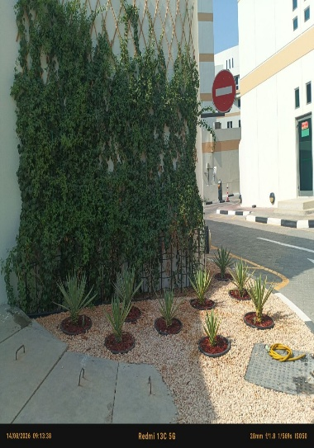 | 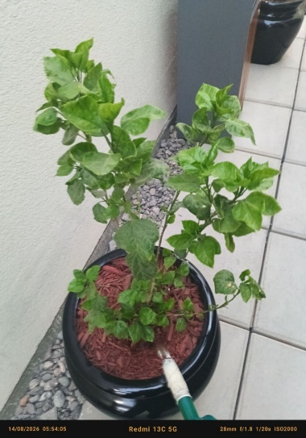 | 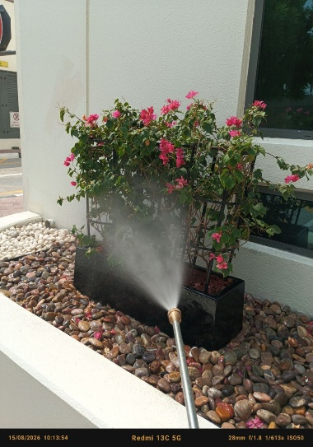 | 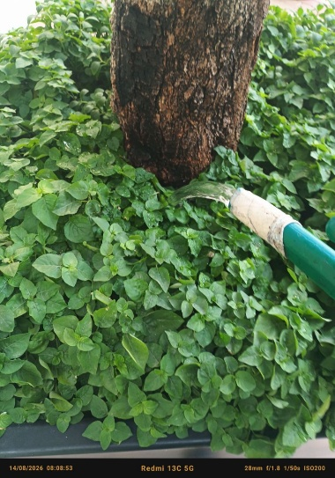
after Manual Watering | Manual Watering | Application of Pesticides | Manual Watering
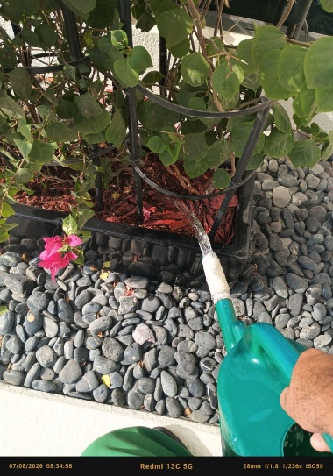 | 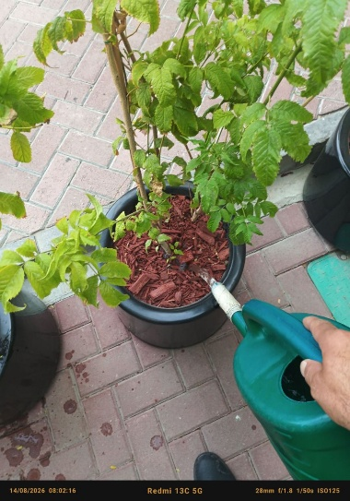 | 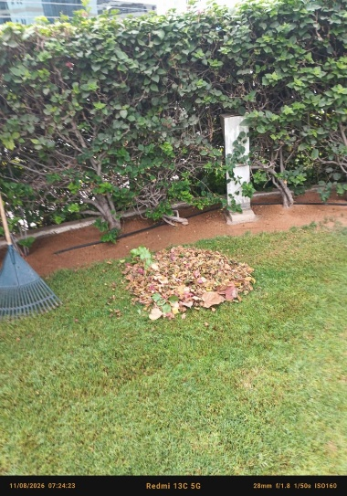 | 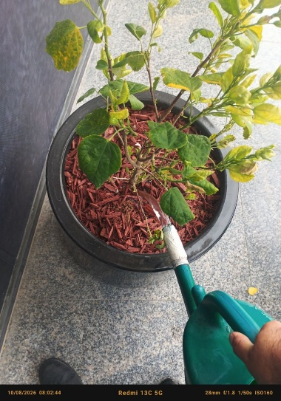
Manual Watering | Manual Watering | Cleaning and Removal of Fallen Dry Leaves | Manual Watering

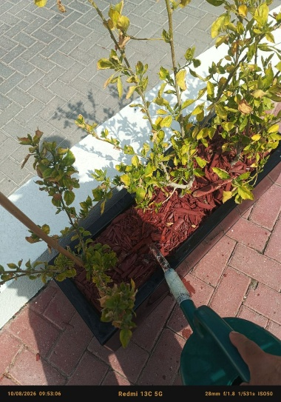 | 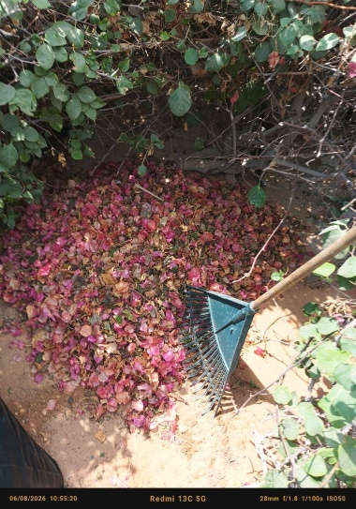 | 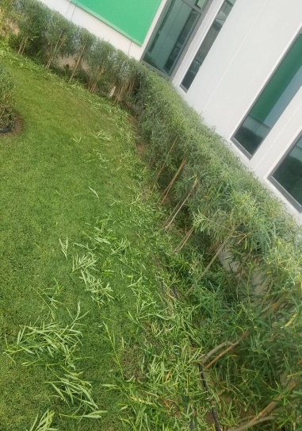 | 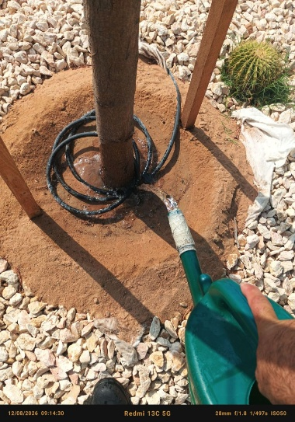
Manual Watering | Cleaning and Removal of Fallen Dry Leaves and petals | Trimming Activity | Manual Watering
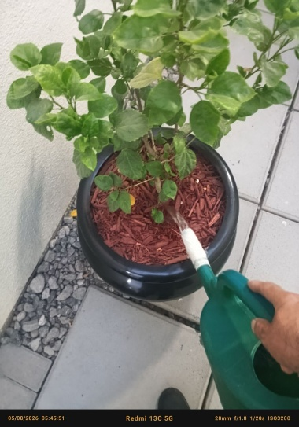 | 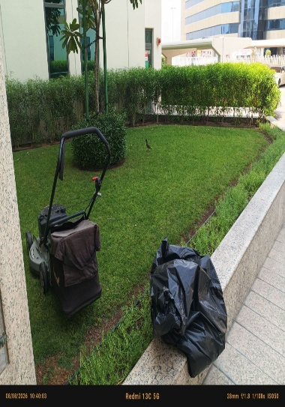 | 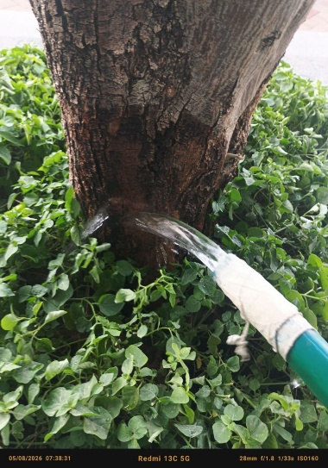 | 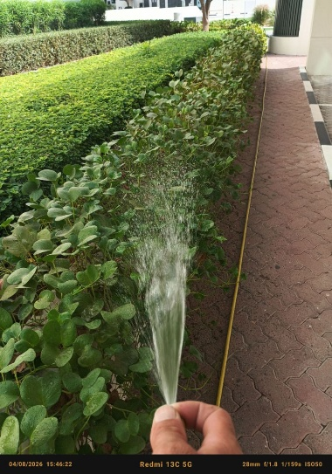
Manual Watering | LAWN MOWING | Manual Watering | Washing of Plants

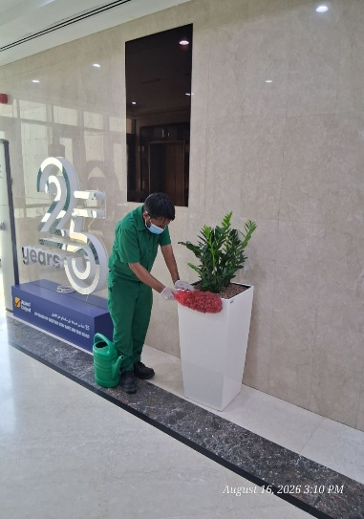 | 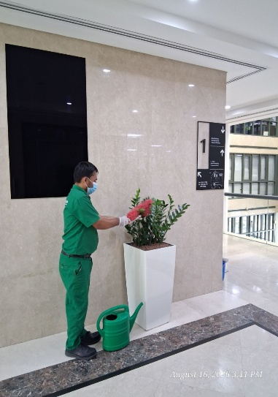 | 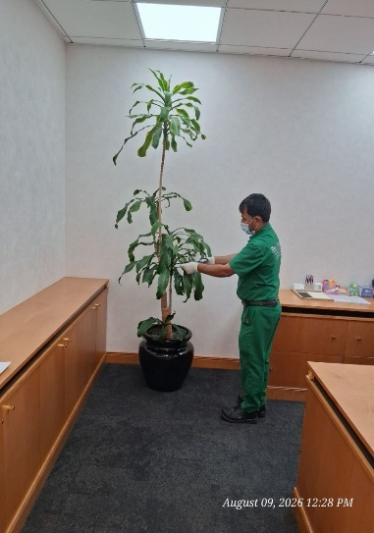 | 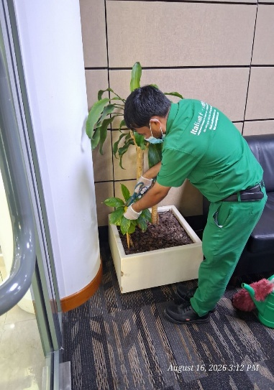
Dusting of Pot | Dusting of Plants | Selective Pruning | Selective Pruning
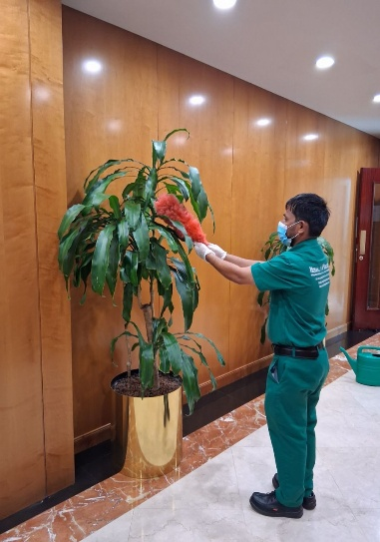 | 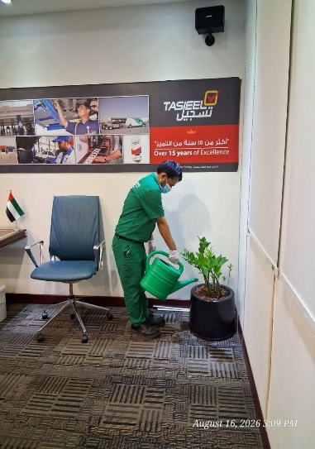 | 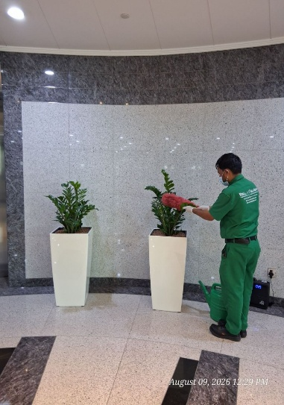 | 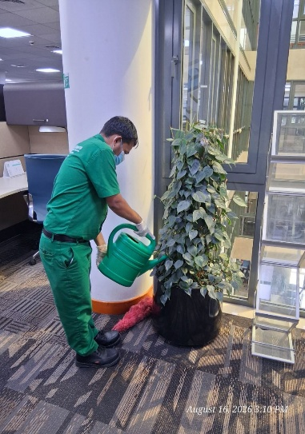
Dusting of Plants | Manual Watering | Dusting of Plants | Manual Watering
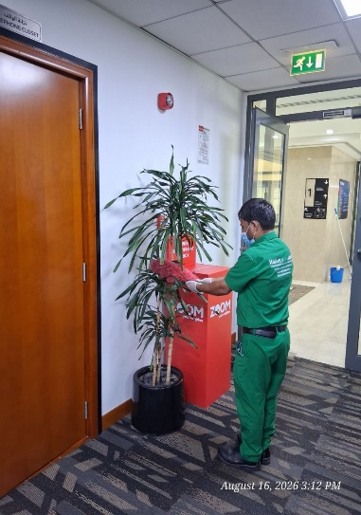 | 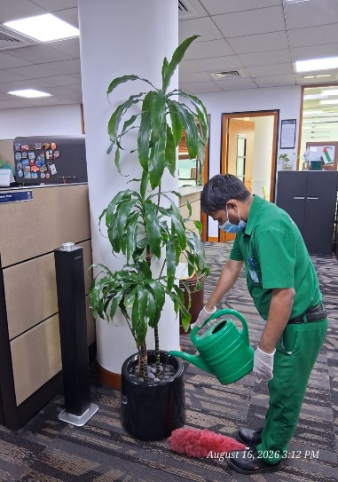 | 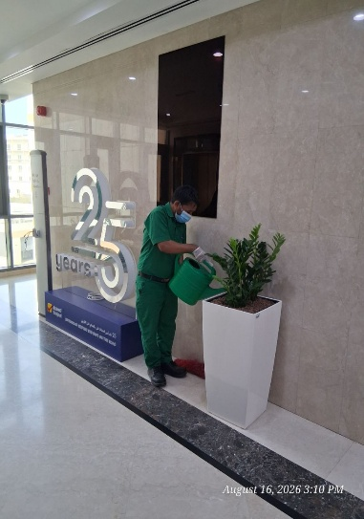 | 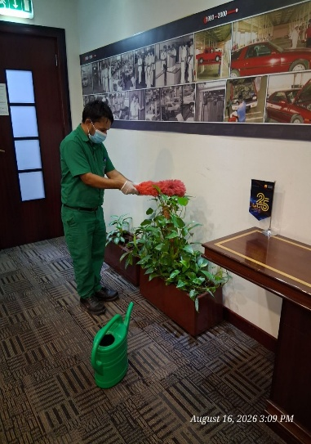
Dusting of Plants | Manual Watering | Manual Watering | Dusting of Plants

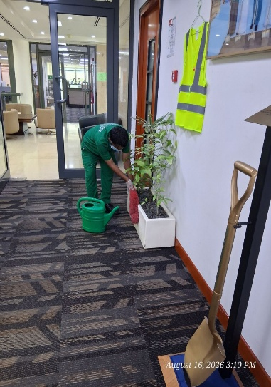 | 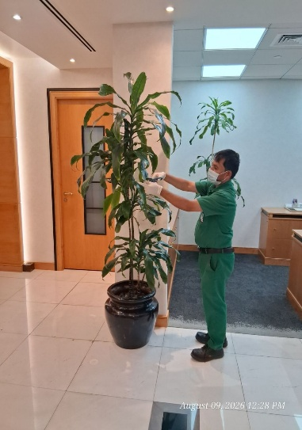 | 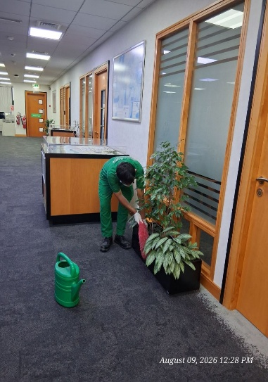 | 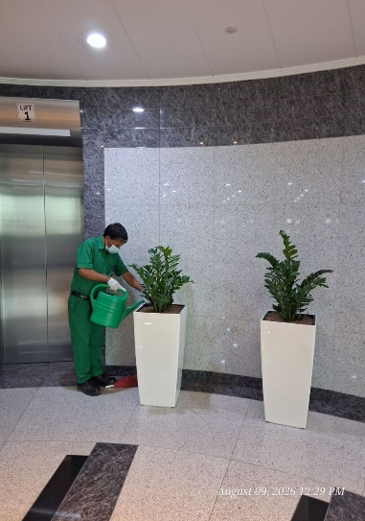
Dusting of Pot | Selective Pruning | Dusting of Pot | Manual Watering
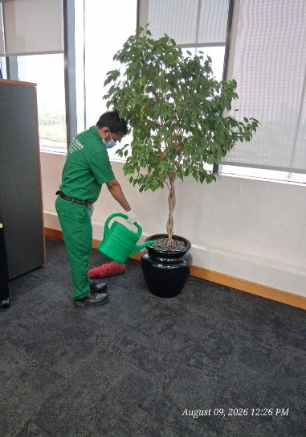 | 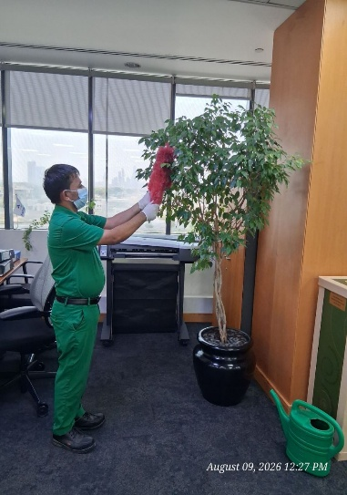 | 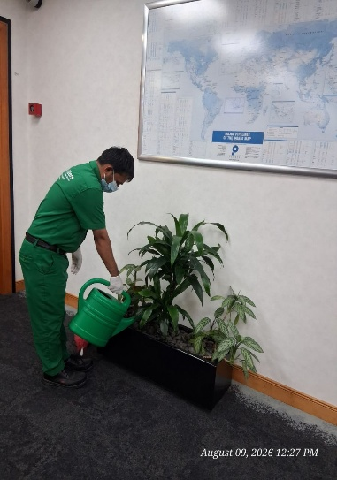 | 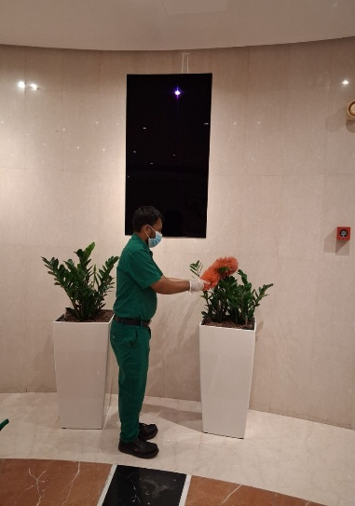
Manual Watering | Dusting of Plants | Manual Watering | Dusting of Plants
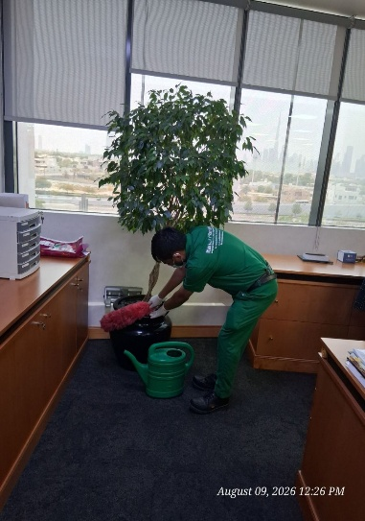 | 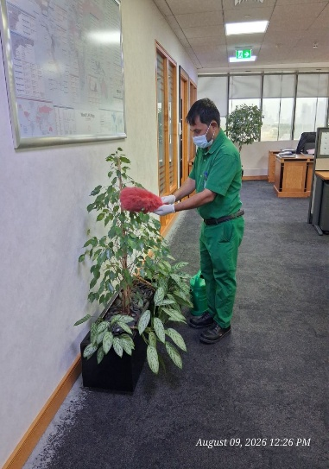 | 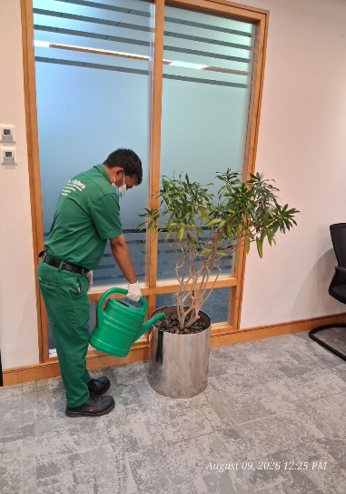 | 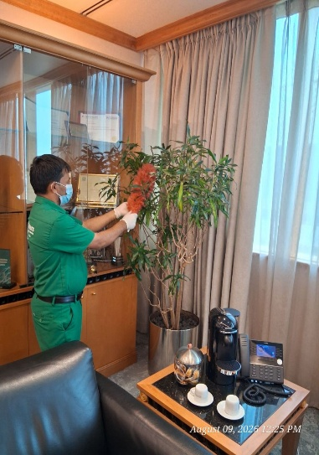
Dusting of Pot | Dusting of Plants | Manual Watering | Dusting of Plants

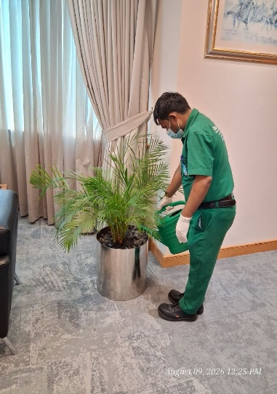 | 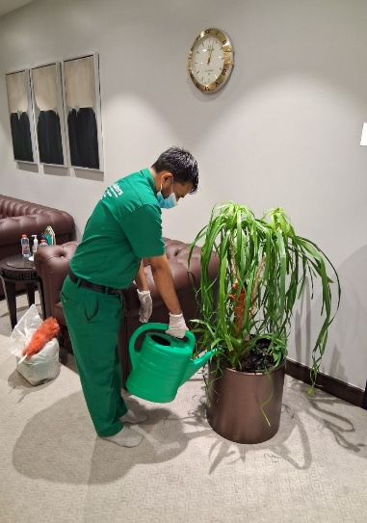 | 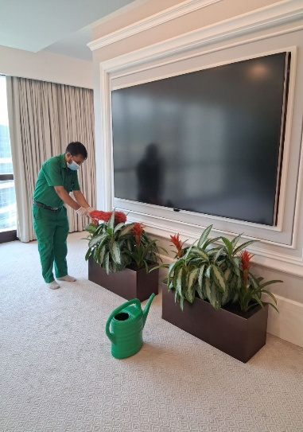 | 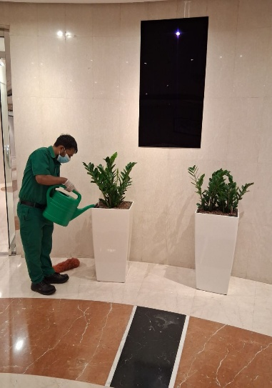
Manual Watering | Manual Watering | Dusting of Plants | Manual Watering
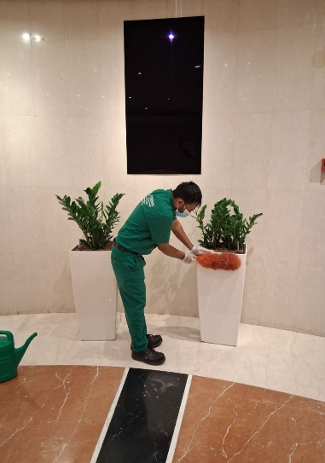 | 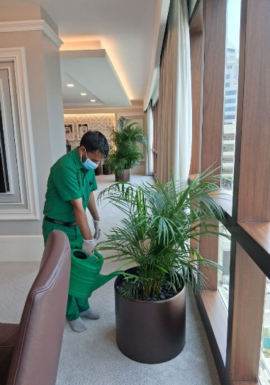 | 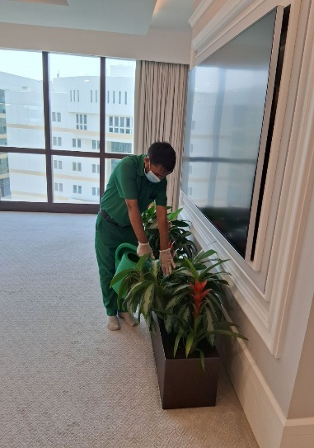 | 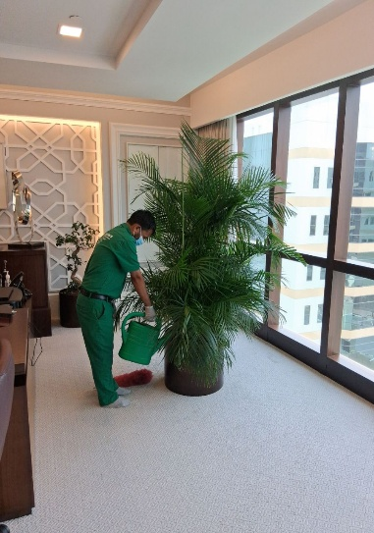
Dusting of Pot | Manual Watering | Manual Watering | Manual Watering

Agriculture Engineer | Basem Adel
Date | 04.09.2026

